Date :10.10.2025 Sprint :20
https://jira-eu-aholddelhaize.atlassian.net/browse/DA-51655
Task: BlueConic – Ingestion (Landing → Raw)
1. Container Creation (Raw + Clean layers)
- Go to ingdll repo → terraform/development/storage-accounts.yaml
- Add new containers for raw and clean layers.
- Repeat the same changes for:
  - development
  - acceptance
  - production
- ✅ Example PR: becse-adp-ingdll #719

2. Grant Unity Catalog Access
- Repo: becse-adp-terraform-framework
- Path: tfvars/unity/catalogs/
- Add environment-specific access details for:
  - dll-dev-raw
  - dll-dev-clean
- ✅ Example PR: terraform-framework #685

3. Mapping in Ingest Core (Landing → Raw)
- Repo: becse-adp-ingest-core
- Add new mapping configuration in CF2 for the dataset.
- ✅ Example PR: ingest-core #146

4. Deploying to Development
- Repo: becse-adp-ingdll
- Go to Actions → Workflows → Azure Function App Workflow
- Run the workflow with appropriate inputs (dataset, environment, etc.)

example:
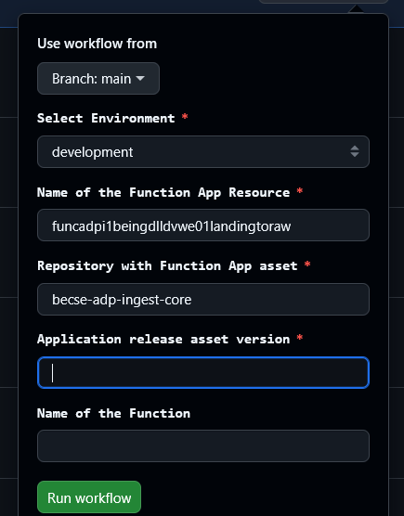

Date:13.10.25
DA- Blueconic - Ingestion raw to clean – Dimensions

